Garden Club of Harrington Park
2018-2019 Meetings and Events

The Garden Club or Harrington Park holds General Meetings the first Thursday of every month (except where otherwise noted) September through June in the Harrington Park Library (second floor). The meetings begin at 7:30 P.M. and include a lecture by a guest speaker on various gardening topics, followed by a Q & A, and refreshments. Each meeting we have a floral contest, whereby members interpret a given theme.

Traditionally, in June we have a field trip and luncheon, and on occasion, we have mini-field trips to a garden, a garden show, or anything garden!

September 6, 2018
Speaker: Caren White, “The Herb Lady”
Garden Steward for the Herb Garden at Rutgers Gardens, Master Gardener
Topic: “Growing Herbs in Containers”

October 4, 2018
Speaker: Marc Zukovich, Owner Sterling Horticultural Services
Topic: “12 Dependable Perennials:
Plus Shrubs for Small Gardens’

November 1, 2018
Speaker: Wiebke Hinsch, Master Gardener, Docent at NYBG
Topic: “Gardening with Bulbs”

November 3, 2018 – Barrel “Greening” 10:00 A.M. – Downtown H.P.
Bring Your Gloves & Trowel

November 18, 2018 - 2:00 P.M. “Thanksgiving Centerpiece Workshop” –Conducted by Gerri Gibney – Fee
Library, Pre-Registration Required – contact themerchantmouse@aol.com or 201 768-2615

December 6, 2018
Speaker: Gerri Gibney
Topic: Hands on Workshop
Wreath and Holiday Arrangements
Make-It and Take-It

December 14, 2018
Garden Club Holiday Get-Together – Pot Luck “Nibbles and Sweets” at Gerri Gibney’s – 7:00 P.M.

January 3, 2019
“Members’ Night & Winners & Losers in the Garden” – A Fun Evening of Garden Club Members’ “Slide Show and Tell” of Their Own Gardens, Gardens Visited, or Anything Garden

February 7, 2019
Speaker: Kathleen Sullivan, Master Gardener, Site Coordinator at the Hermitage
Topic: “Plants from the 18th Century to WW1; Creating Historical Gardens”

February 23, 2019 – Mini Field Trip to Connecticut Flower Show – Depart Library Parking Lot 8:00 A.M. Luncheon to Follow – Fee

March 7, 2019
Speaker: Bruce Crawford, Director of Rutgers University Gardens
Topic: “Mixed Borders – Thoughts on Blending Shrubs and Perennials”

April 4, 2019
Speaker: Donna Dorsey, Owner/Operator Goffle Brook Farm, Ridgewood, New Jersey
Topic: “What’s New & Exciting & My Trade Secrets”

April 27, 2019 – Garden Club Plant Sale (Many Homegrown Plants) – Annual Fundraiser held at the Library Parking Lot – 9:00 A.M. – Noon

May 2, 2019 – Plant Swap
Speaker: Gerri Gibney
Topic: “A Brief History of Garden Furniture: From Stone Seats to Fashionable Furnishings”

May 11, 2019– Barrel Planting -
10:00 A.M.
Beautification of Downtown H.P.

June 1, 2019 – 10:00 A.M.
Tour of Members’ Gardens and Pot Luck Barbecue

June 15, 2019 – Field Trip & Luncheon
Depart Library Parking Lot at 9:00 A.M. – Beatrix Farrand Garden, Hyde Park, N.Y. – Luncheon at
Le Bouchon, Cold Spring, New York

Possible Overnight Field Trip in June to
Pennsylvania Gardens –

STAY TUNED!

Garden Club of Harrington Park
Membership

Membership is open to anyone with a love of gardening. Whether you are an arm chair gardener or an on your knees dirt gardener – we welcome all. Incidentally, we have both men and women members in our Club – we were one of the first garden clubs in New Jersey to have both, because, since our inception we have met in the evening! You do not have to be a resident of Harrington Park, many of our members are from surrounding towns.

Our dues are:
Individual - $20.00
Family - $35.00

If you are interested in becoming a member of the Garden Club, please send your check, made payable to the Garden Club of Harrington Park, to Beverly Murray, 363 High St., Closter NJ 07624-2004. Please include your address, phone number, and e-mail.

Opportunities for Fun

You can enjoy the Garden Club in so many ways; by attending our meetings, and/or volunteering to be a refreshment host, helping with special events, and, if you would like, jumping in with both hands for some of our on-going dirt projects, such as the barrel plantings in the downtown area.

These barrels have been purchased and maintained by the Club. Each year we replace the old barrels, if needed, and plant flowers to be enjoyed in the spring, summer, and early fall. Come late fall we replace the spent flowers with evergreens to last the winter into the early spring. During the growing season, you might want to join the “Water Wizards.” The Wizards sign-up to water the plant life in the barrels to keep them fresh and beautiful.

This Club year we plan to have a Spring Plant Sale for our fundraiser. This will need helping hands too.

Affiliations

We are members of the Garden Club of New Jersey and the Garden Club of America.

Information about the Garden Club, please call Gerri Gibney at 201 768-2615 or 201 913-8459, themerchantmouse@aol.com – We’re on Facebook – friend us!
www.gardenclubofharringtonpark.com

May 2019 - It’s Our 29th Anniversary!
NOTES

Garden Club
of
Harrington Park
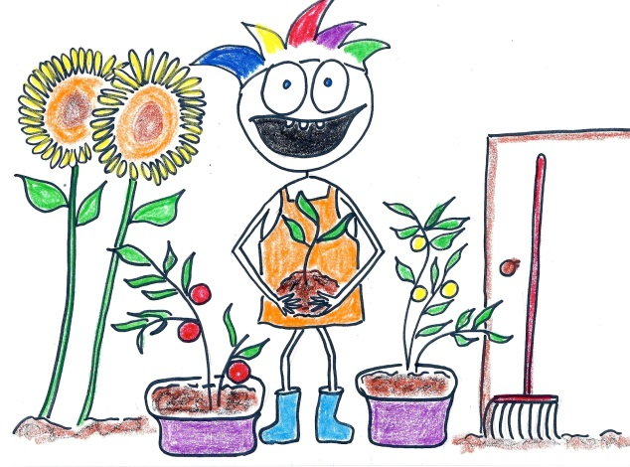
Meetings
and
Events

2018 - 2019

