GARDEN CLUB OF HARRINGTON PARK
2020 PLANT SALE - ANNUALS
FLATS
Full Flat (32 Plants) - $20.00 / Half Flat (16 Plants) - $12.00

 AGERATUM (Floss Flower) Hawaii Royal Blue - clusters of small blue fringed fuzzy flowers smother shapely compact mounds from spring to fall; a favorite for beds, borders, edgings, mass plantings, rock gardens, ground covers and containers; vigorous, easy, attracts Butterflies, heat tolerant, sun, 5-6" HT, sun - light shade

ALYSSUM Clear Crystal (Lobularia)
A dense herbaceous annual with fragrant flowers and a low trailing habit of growth, eventually spilling over the edges of hanging baskets and containers; brings an extremely fine and delicate texture to the garden; attracts bees, butterflies, hummingbirds; deer resistant; low maintenance; blooms spring through fall; 6 – 10” ht, 12 - 14” spread; full sun to part shade
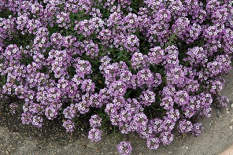 Clear Crystal Lavender – dainty lavender-shades flowers w/ grayish green leaves.

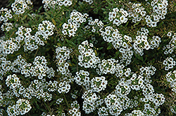 Clear Crystal White – clear white star shaped fragrant flowers, narrow grayish green leaves;
BEGONIA (Semperflorens)
Tender annual produces single or double one-inch ever-blooming flowers in every shade of red, white and pink on succulent stems among shiny bronze or green leaves, providing color in sun or shade from late spring until frost; tolerate hot humid conditions; sometimes called "wax type" because of the waxy look to the leaves.

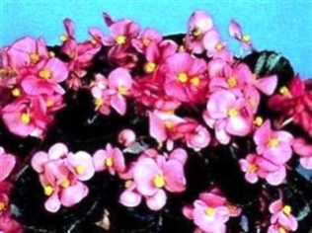 Gin – bright rose pink blossoms, dark green foliage, 6-8” ht & spread
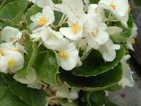 Olympia White - large .75" white flowers on green foliage, 6-8” Ht, 12” spread
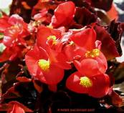 Vodka – a non-stop display of red blooms and burgundy leaves; 10 – 12” ht & spread
 Whiskey – brilliant white blossoms w/ yellow center; glossy bronze leaves; blooms all summer, compact; 6”-8” ht, 8”-10” spread
CELOSIA
A showy easy to grow unique flower, commonly known as “Cocks Comb” for its unusual display of feathery “rooster comb” plumes; attracts bees / butterflies; good for cut flower / dried flower; late spring through fall; full sun to part shade
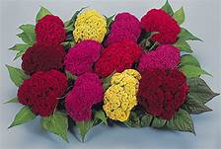 Amigo Mix – crested mixture of reds, pinks, oranges & yellows; 6 – 8” x 4 – 6”
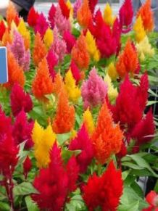 Ice Cream Mix – large tight flower plumes in Banana, Cherry, Mango, Orange, Peach & Strawberry; ht. 10 – 12”; spread 8 – 12”

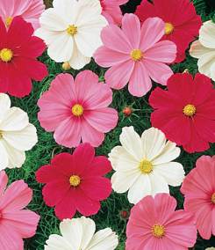 COSMOS Sonata Mix - bright, colorful daisy-like blooms w/ ferny leaves. Mix includes white, rose, pink and cherry. Drought / heat tolerant; 18”- 24” ht; 12” -14” spread
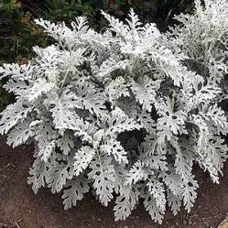 DUSTY MILLER Silver Dust – delicate lacy deeply lobed silvery-white velvety foliage; excellent for borders, edgings and pots; upright spreading habit; 12” ht x 12” spread; full sun to partial shade
IMPATIENS
Abundant flowers in broad color range; vigorous; uniform habit, mounded, upright; low maintenance; good for containers, hanging baskets, border edging, general garden use; a must have for shade gardens; pt SUN to full shade.

The Beacon™ Impatiens* offers high resistance to the currently known and widely prevalent populations of Plasmopara obducens, the pathogen that causes Impatiens downy mildew. They are low maintenance and shade tolerant.

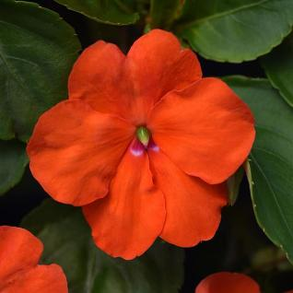 *Beacon Orange – stunning bright orange flowers on upright mounded plants; ht. 15 – 20” x 12 – 14” w.

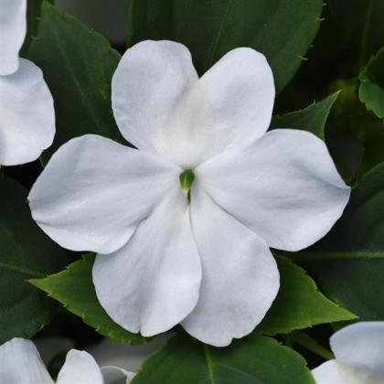 *Beacon White – pure white blossoms on moderately vigorous, upright mounded plants with mid-green foliage; ht. 15 – 20”; w. 12 – 14”

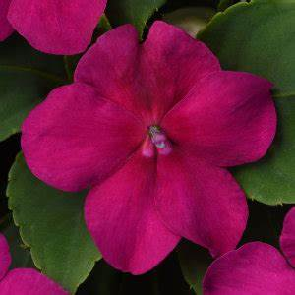 * Beacon Violet – exciting clear bright violet flowers spring through fall; ht. 15 – 20”; w. 12 – 14”

Super Elfin Impatiens Characteristics: low deer tolerance; ht. 8 – 10”, spread 12 – 14”; part to full shade

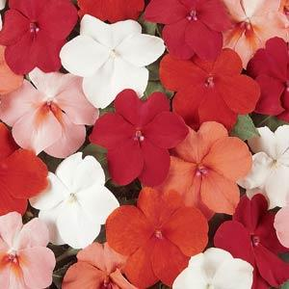 SE Cha Cha Mix - white, red, orange, & cherry splash flowers;

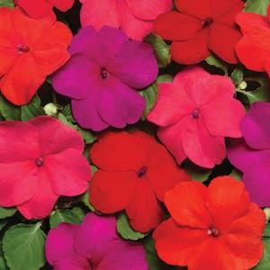 SE Hot Mix – vivid mounding blooms in scarlet, red, violet and punch (bright maraschino cherry)

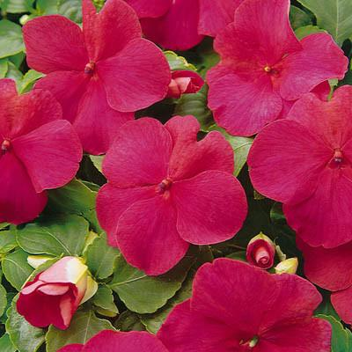 SE Lipstick – blooms of bright salmon-rose with white eye

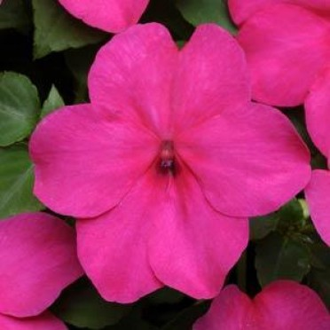 SE Rose – abundant bright rose blooms; mounded upright

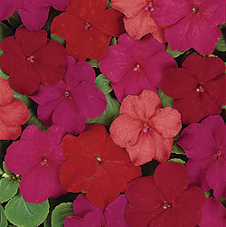 SE Samba Mix - vibrant mix of ruby, lipstick, violet, scarlet, and salmon

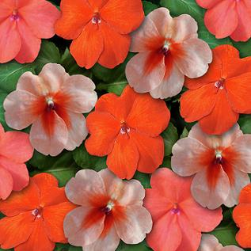 SE Sedona Mix – southwest dessert theme – orange, salmon & salmon splash

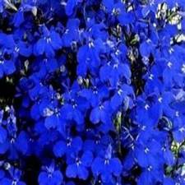 Lobelia Riviera Midnight Blue – showy dainty deep blue flowers with white eyes from mid spring to mid fall; tiny narrow green-bronze foliage; mounded habit 4 – 6” ht; spreads / trails to 8”; pt sun

MARIGOLD
Easy to grow, bloom brightly all summer long in pots, borders and window boxes; attracts bees, butterflies, birds; fragrant; deer resistant, drought tolerant; xeriscaping; good cut / dried flower; planted as a companion to more vulnerable flowers and vegetables may repel nematodes, cutworms and rabbits. They're also a bright and nutritious addition to your table adding color and a spicy tang to salads and other summer dishes. Prefers full sun but will grow in partial shade.

 Boy Spry - double blooms w/ deep yellow centers & rusty orange outer coronas, , 8”-1’ ht, 1’-2’ w
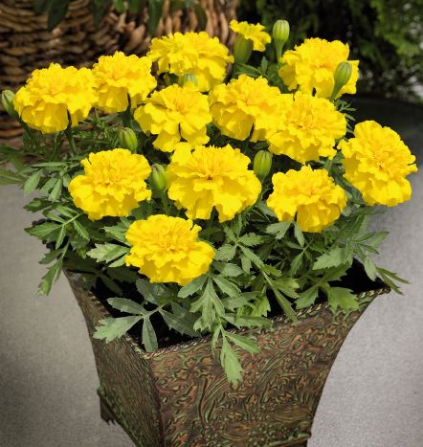 Little Hero Yellow – masses of bold yellow pincushion flowers from late spring to late summer – excellent for cutting; dark green fragrant fuzzy leaves; upright spreading habit; good for garden, pots; 10” ht, 12” spread

 Disco Marietta – large 2” golden yellow blossoms with mahogany blotches; upright; heat tolerant; 10-12” ht & spread

 Durango Bee - 2 to 2-1/2" uniquely colored mahogany-edged yellow anemone type flowers supported by strong stems on well-branched plants; 10 to 12" ht, 6 to 8" spread.

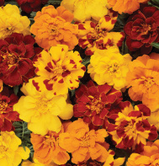 Durango Outback Mix - Extra-large 2-2 1/2" double red-tipped yellow bolero accents deep red, tangerine and yellow blooms on bushy, vigorous, dark green plants; Ht. 10 - 12", 6 – 8” spread

NICOTIANA (Flowering Tobacco)
Easy to grow; features trumpet-like flowers; perfect for mixed borders or containers; fragrant; attract hummingbirds, butterflies; deer & gopher resistant; sun to shade; poisonous if ingested

 Saratoga Purple Bi-Color- fragrant bi-color purple tubular star-shaped flowers on bushy compact plants; 10 - 12” x 10 - 12”

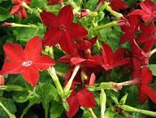 Saratoga Red – eye-catching bright deep red flowers are held upright for maximum visual impact; bushy; ht. 8 – 12” x 10 - 12’ w

SALVIA
Intense color for landscape, containers, mixed beds; attracts butterflies, birds, hummingbirds; drought resistant, deer resistant; low maintenance; sun to mostly sun

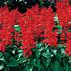 Flare – intense vivid scarlet-red bloom spikes; unbelievable in a mass planting; tall, bushy, vigorous - grows in those blazing trouble spots where little else has been successful; remarkably floriferous over an extra-long season; thrives on neglect! 18 – 20” ht, 12 – 16” Spread

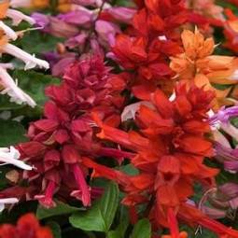 Sizzler Red - masses of beautiful spikes of bright scarlet red tubular flowers with red calyces rising above dark to medium green foliage from late spring to early fall; ht. 10 – 12”, spread 8 – 10”

AIM – 2/29/20

