GARDEN CLUB OF HARRINGTON PARK
2020 PLANT SALE - ANNUALS IN POTS

5” POTS – “PROVEN WINNERS” - $7.00 EACH

EXCEPTION: GRASS PRINCE TUT 1 Gal. - $10.00 Each

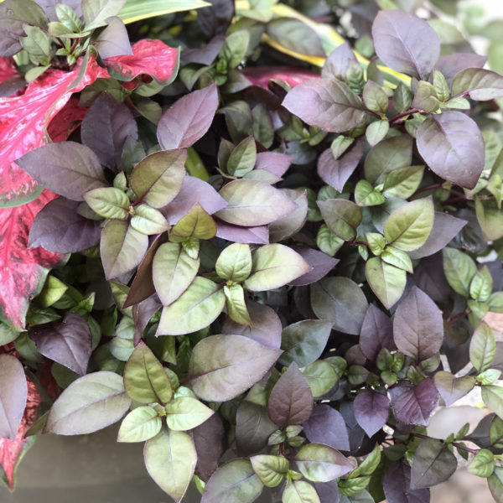 ALTERNANTHER Plum Dandy – showy pointy plum leaves with rose undersides and crimson stems; dense, heat loving, ground-hugging; great for containers, edging, mass plantings, ground cover; tolerates partial shade, but most vivid color in full sun; mature height 16”, spread 18”

BEGONIA (Tuberous)
Among the most elegant of shade-loving plants, these tender bulbs brighten shady gardens as no other plant can with big, bold single or double blooms; many have an arching plant habit making them excellent for hanging baskets and containers. Tubers may be stored over winter.

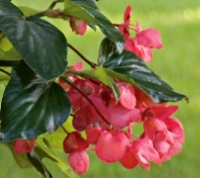 Dragon Wing Pink - very heat tolerant, has wing-like, glossy green leaves, excellent in containers / hanging baskets, mounded, thriller; full sun/ full shade, 14-18” HT

 Dragon Wing Red - vigorous and heat tolerant with abundant flowers all summer; deadheading not necessary; great plant to fill open shady spaces; 14”x 18”

CALIBRACHOA Superbells (SB)
Petunia look-alikes; compact and bushy even when stressed; covered with hundreds of flowers from late spring to early frost; long, trailing branches; attracts butterflies and hummingbirds; heat tolerant; no deadheading; mounding/trailing spiller; sun

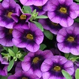 Blue Moon - masses of silvery lavender flowers adorned with a deep purple eye; ht 6” – 12”; trails up to 30”

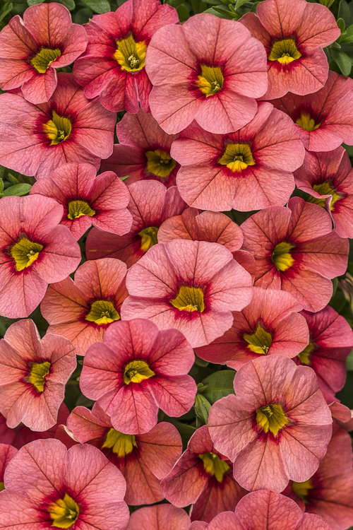 Coralina - boasting coral-pink flowers adorned with a coral-red throat; 6” – 10”; max spread: 12” – 24”

 Double Love Swept – small, double petunia like flowers of bright pink with white edging; 6 - 10” ht, 12” – 24” spread, trails to 16”

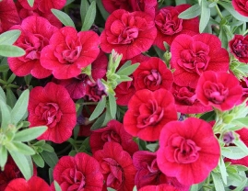 Double Ruby – boasts masses of dazzling ruby red double flowers; 6-12” ht, 12 -24” wide, trails to 12” long

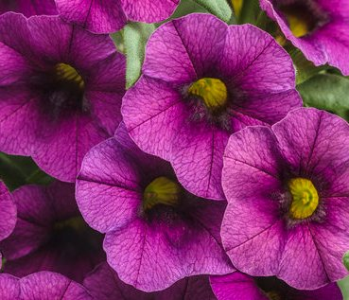 Plum – lovely rich plum blooms with yellow eye; ht 6-12”, spread 12-24” wide, trails to 24”

 Lemon Slice – bright yellow and white blossoms w/ unique pinwheel pattern; 8-10” ht; mounding/ trailing to 24”

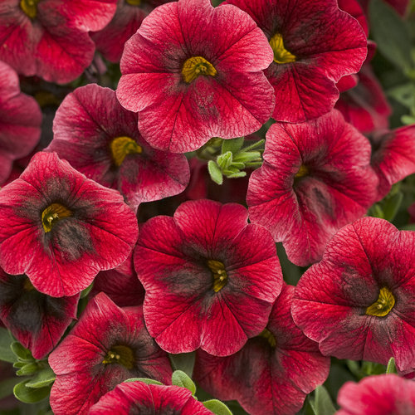 Pomegranate Punch - rich velvet red with prominent black center; 6-12” ht, spread 12- 24”, trails to 24”

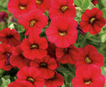 Red - deep crimson red blooms w/ black throat; 6-10” ht, spread 18-24”, trails to 48”
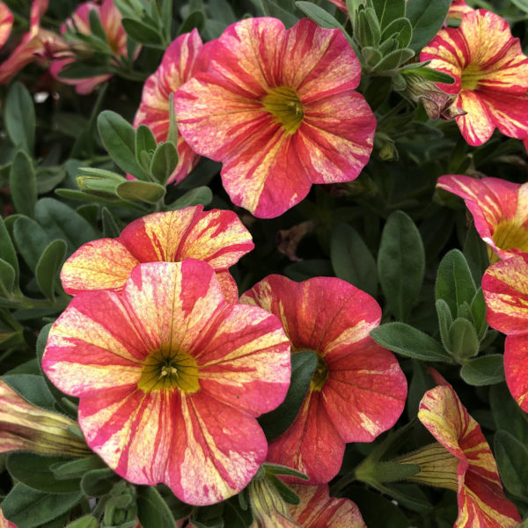 Tropical Sunrise – bright flowers adorned with pink, yellow and red streaks; 6” -12” ht; 1’ -2’ spread

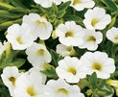 White - pure white blooms are nicely set off with yellow throats; 6-10” ht, 18-24” spread, trails up to 48”
DIANTHUS Telstar
An early flowering herbaceous evergreen hybrid variety of “Pinks” which produce a prolific display of vibrant fragrant flowers on uniform compact mounds from spring throughout summer; brings an extremely fine and delicate texture to the garden; excellent heat tolerance; bred to have a high degree of resistance to Phytophthora and other damp-off pathogens; deer & rabbit resistant; ht: 6 – 8” ht; sun

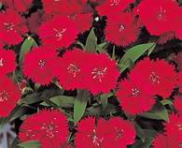 Crimson - amazing lacey edged bright crimson blooms with bright green leaves; best example of Dianthus available as a separate color

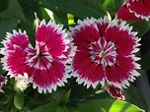 Red Picotee – striking crimson red flowers with white serrated picotee and blue-green foliage; an AAS winner.

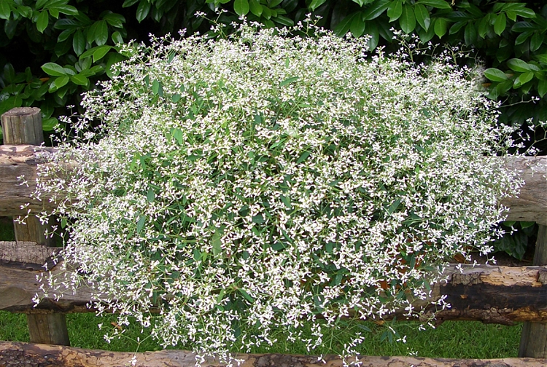 EUPHORBIA Diamond Frost - produces non-stop, spring to fall, masses of showy pure white bracts, reminiscent of baby’s breath, above finely textured, gray-green foliage; low maintenance / heat/drought resistant; deer/ rabbit / critter resistant; great for beds, borders, containers; filler; sun/ pt sun/ some shade; 1 -2’ ht & spread
EVOLVUS Blue my Mind - low spreading true blue morning glory non-stop nickel-sized blooms throughout summer and fall, w/ grey-green foliage, use as an unusual & stunning groundcover or in hanging baskets /containers; heat tolerant, self-cleaning; full sun; mounding/trailing, 6-12" ht, trails to 24”

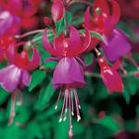 FUCHSIA Shadow Dancer Marcia - little hot pink balls of color burst open to purple bell shaped flowers that contrast with the deep green foliage, adds a mass of color to part shade to shade gardens; Hummingbird favorite; full shade, part sun; ht. 8-12”; spread 1 – 2’
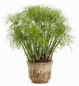GRASSES CYPERUS Prince Tut - a/k/a Dwarf Egyption Papyrus; erect, triangular stems that sprout from woody rhizomes. Atop the stem rests a rounded umbel adorned with many slender arching threads. provides interesting foliage; water garden friendly; grows well in landscape, inter-mingles w/ plants to fill in the middle ground of a combination planter, full sun- pt shade, 18-24" ht, 14-20" spread NOTE: COMES IN 1 GAL. CONTAINER @ $10.00

HELICHRYSUM (Licorice Plant)
Licorice plant is grown for its silvery to gray-green densely-felted foliage and trailing habit; upright to trailing stems are densely clad with soft, woolly, oval-rounded leaves; rapid grower; good filler foliage plant that adds contrast and procumbent form to hanging baskets and containers; ground cover; trail over a stone wall; edger; heat/drought resistant; pt sun to full sun; easy

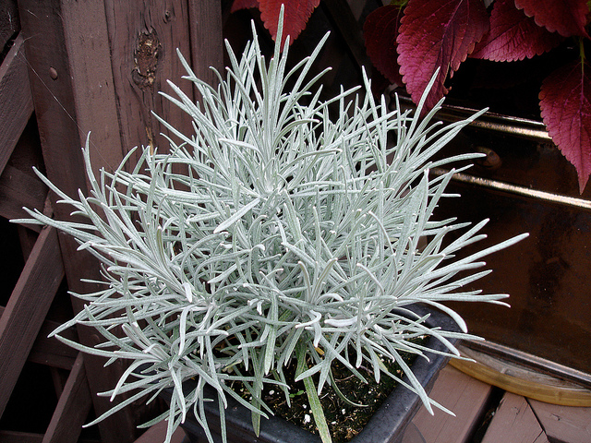 Icicles – long, elegant intensely silver foliage, upright, filler; 16-18” ht / 18-20” spread

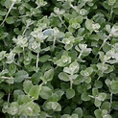 Petite Licorice - Compact grower with dainty silver-green leaves; upright habit; ht: 8-12”, 10-14”
 White Licorice - super silver-hued foliage plant; cool backdrop for pastels & jewel tones; trailing; 8-12” ht; 18-20” spread
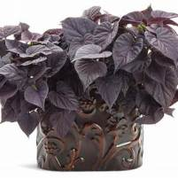 IPOMOEA (A/K/A “Sweet Potato Vine”) Sweetheart Jet Black - deep purple (as close to true black as you can get) heart-shaped foliage for pots, hanging baskets, garden; works great in landscapes as ground cover; easy to grow; heat tolerant and happy in full sun / pt sun; ht. 6 – 16”; trails up to 30”; spread 20-26”, spiller

LANTANA
Aromatic flower clusters in mixes of red, orange, yellow, blue & white florets; flowers typically change color as they mature, resulting in inflorescences that are two or three-colored. Perfect for hanging containers, flower boxes or for making a stunning sprawling ground cover in your garden; low maintenance; prefers full sun; attractive to butterflies and other helpful pollinators; drought resistant; heat loving.

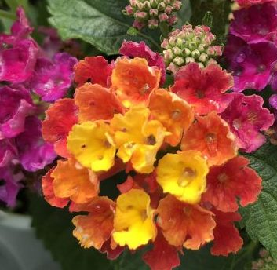 Bandana Cherry Sunrise - one of the most exciting colors of the BANDANA® series, because its flowers combine 4 colors: yellow centers, followed by rings of apricot, pink, and an outer circle of bright crimson; offers larger flowers; a nice trailing habit; ht: 1 – 2’; spread 2 - 3”; filler
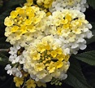 Bandana Lemon Zest - bright yellow to light yellow flowers on a well-branched plant; nice mounding habit; 2′ high and wide

 Luscious Citrus Blend - heat-loving selection with vibrant red, orange and yellow flowers on a mounding plant that grows to 3’ Ht & spread
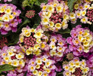 Luscious Pinkberry Blend - tones of pink, yellow and cream produce a gorgeous display of color; mounded; 20-24 “ht; 24-36” spread
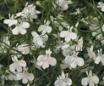 LOBELIA Laguna White - white flowers all season on cascading plants; full sun to partial shade; prefers moist, rich soil; attracts butterflies good summer performance; low maintenance; 8-10” ht; 12-18” spread; trails to 24”

 LOBULARIA Snow Princess - snowballs of tiny white flowers just keep on coming; Honey-scented Alyssum that blooms until hard frost without deadheading; attracts butterflies, hummingbirds, bees; heat tolerant; filler / spiller; full sun- pt shade; 4-8” ht, trails to 24” (A BRUCE CRAWFORD RECOMMENDATION!)

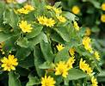 MELAMPODIUM Lemon Delight – “Butter Daisy”, profusion of sunshine yellow flowers on deep green leaves all summer; containers, borders; tidy compact habit; sun; 6-12” ht, 10” w
NEMESIA
Blooms through frosts; excellent early spring & late fall; no deadheading; good for hanging baskets, window boxes, beds; pt sun to sun

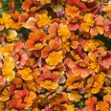 Blood Orange - burst of rich oranges, yellows and red with beautiful ruffled petals; wonderful during the hot months; self-cleaning; 10 – 14” ht, 12 – 16” spread

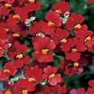 Cranberry Red – a cascade of beautiful red flowers all season; excellent for early spring; low maintenance; self-cleaning; prefers good drainage; attracts birds; mounded; ht. 6- 10”; spread 12 – 16”; trails to 18”

PENTAS
Large clusters of star-like flowers summer long till frost; irresistible to butterflies, hummingbirds and bees; dark-green lanceolate leaves; easy, no deadheading; great for beds, borders, and containers; compact growth; deer resistant; thrives in hot summer conditions; full sun to pt shade
 Graffiti Lipstick - enormous clusters of brilliant cherry-red, five point flowers that are humidity proof; ht. 14”; spacing 15”
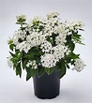 Graffiti White – elegant pure white blooms; ht. 12”- 15” ht & spread
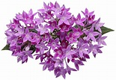 Sunstar Lavender - large clusters of lavender flowers on dark green foliage all season; ht. 18 – 20”; spread 16 – 24”

PETUNIA Supertunia
Exceptional fail-proof favorites no matter how or where you use them. Prolific bloomers from mid-spring through late fall with nearly limitless color choices, some sporting beautiful veinings. They create extraordinary hanging baskets and containers because their compact habit means they fill in quickly and don’t get leggy; function as both filler and spillers. In the landscape they grow vigorously and can be planted much further apart than other petunias; self cleaning; attract hummingbirds, bees, butterflies; sun / pt sun

 Limoncello – soft yellow w/ deep yellow veins; 6 – 10” ht x 10 – 24” wide, trails to 24”
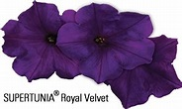 Royal Velvet - medium-to-large vivid purple flowers; ht. 6 – 12”; spread 18 – 24”
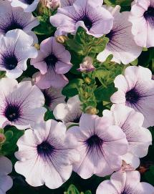 Trailing Blue Veined - white to light lavender colored blooms with distinct blue-purple veining and center; ht 4 – 8”; spread 24 – 36”, trails to 36”

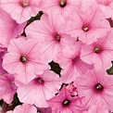 Super Vista Bubble Gum - masses of slightly fragrant, bright 2” bubblegum-pink flowers, 2 in, ht. 1 – 2’; spread 2 – 3’, trails to 36”
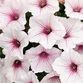 Super Vista Silverberry - masses of bright silvery-white flowers adorned with red veins; semi-upright/cascading; 1-2’ ht; 2 – 3’ spread; trails to 3’

PHLOX
Provides vibrant color from spring thru fall; heat, cold & drought tolerant; low maintenance; self-cleaning; great filler for baskets, planters; attracts butterflies, hummingbirds; mound form, sun to part shade

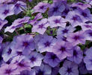 Intensia Blueberry – intense blue-violet color; 10 – 12” ht x 8 – 12’ spread

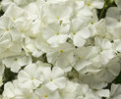 Intensia White – pure white flowers, 10 – 12” x 10 – 12”

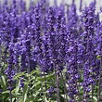 SALVIA Victoria Blue - rich violet-blue flower spikes resembling lavender on square erect multi-stemmed; compact; ht. 1 ½ to 3”

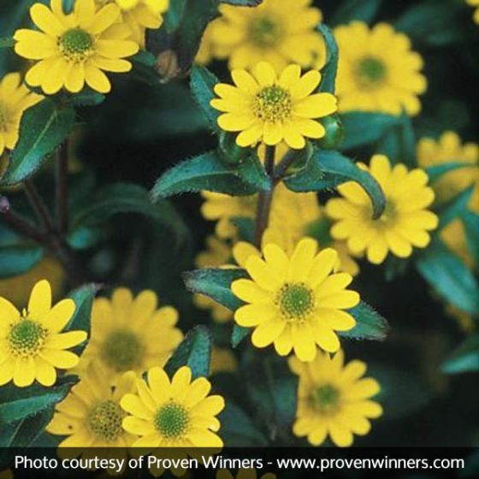 SANTIVALIA Sunbini (creeping Zinnia) - Petite, bright yellow flowers on extremely heat-tolerant plants; low maintenance; sun; 6-10” ht, mounding, trails to 20”

SCAEVOLA
Ever-blooming fan flowers; attractive foliage; no deadheading; drought/heat tolerant; compact open prostrate growth habit; great feature in borders, hanging baskets, pots, or to fill in an area in landscaping beds; full sun/pt shade

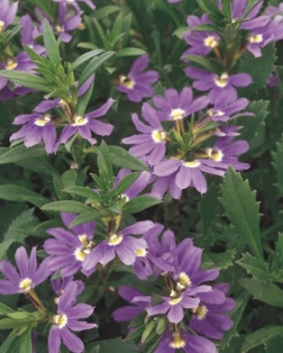 Whirlwind Blue - blue-purple flowers w/ white throat;, 8-12" ht, 10'14" spread, trails to 24”

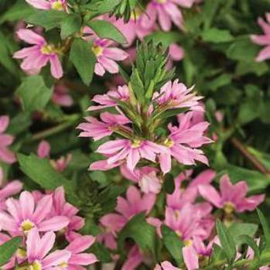 Whirlwind Pink - whorls of soft pink flowers accented by darker pink rays that add sparkle to containers and borders; 8 – 14” HT; 18 – 24” spread; trails to 24”

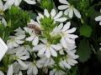 Whirlwind White – pure white flowers; 8 – 14” ht, trails to 24”

 STROBILANTHES Persian Shield – 4 – 7” deep green veined slightly serrated slender leaves with purple to silver on the entire surface tipped with a point; bushy habit; ht 3 – 4 ‘ x 2 – 3 w.

SUNPATIENS Compact Impatiens Series
Can’t be beat for easy care & non-stop color; aside from regular watering, compact SunPatiens are virtually maintenance free; self-cleaning; love the heat; flourish in full sun to part shade; great in containers or landscape; mounding upright habit, filler; unaffected by downy mildew; critter resistant; ht. 16- 28”, spread. 14 – 24 “

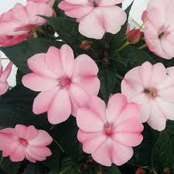 Blush Pink – large flowers are the softest of pinks with an occasional touch of magenta

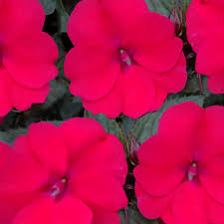 Deep Rose - deep rose-colored single blossoms amongst dark green, lance-shaped leaves

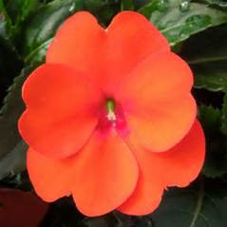 Electric Orange – vibrant orange single blossoms; 18-32” ht; 14”-24” w

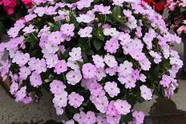 Orchid Blush – NEW COLOR – continuous blooming eye-popping 2-tone orchid flowers
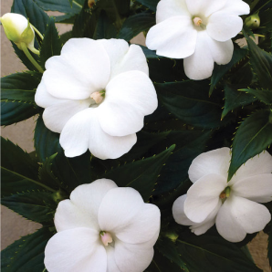 White – large showy white blossoms

SUTERA (common name Bacopa)
A member of the snapdragon family: scores of small five loved tubular flowers appear all season on long strongly trailing plants; low maintenance; perfect filler in hanging baskets, window boxes, mixed garden containers, retaining walls, rockeries; full sun to pt shade

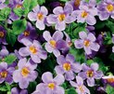 Snowstorm Blue - long cascading stems smothered with stunning lavender star-shaped flowers w/ golden eyes, small serrated green leaves; 4-8”ht, 8”w, trails to 36”

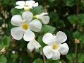 Snowstorm Giant Snowflake – masses of white flowers; 4-8" ht, 8-10" spread, trails to 36”

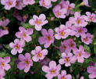 Snowstorm Pink – large soft pink blossoms w/ deeper pink centers and harvest gold eyes; 4-8” ht, 8” w, trails to 36”

TORENIA
Showy “Wishbone” flowers bloom abundantly on small bushy plants; great choice for hanging baskets, containers and edgings; unique mounding, trailing habit; low maintenance; sun to shade

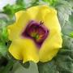 Catalina Gilded Grape - bright yellow tubular flowers with purple throats & small bright green coarsely toothed leaves: 16” ht, trails to 24”

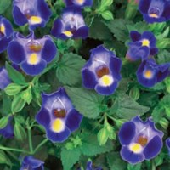 Catalina Midnight Blue - showy royal blue tubular flowers with sky blue overtones and yellow throats, dense foliage; small fragrant pointy leaves; 12-18” ht, 12” spread, trails to 24”

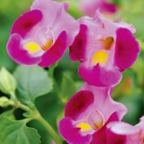 Catalina Pink - lovely shades of pink snapdragon-like flowers all season;, heat & shade tolerant; 10-16" ht, 8-10" spread, trails to 24”

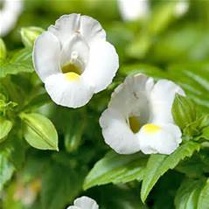 Catalina White Linen – deep-throated white bloom w/ soft yellow center; 8-16” ht, trails to 24”

VERBENA Superbena Royale
One of those garden essentials that blooms from spring to fall with very little fuss. Superbenas feature large star-shaped flowers and umbels; bloom earlier than regular verbenas; very vigorous and mounded, but will trail over the sides of containers functioning as both spillers and fillers; great in containers, front of beds, ground covers; butterfly magnet; deer resistant; drought resistant/heat tolerant; bloom early and all season long; excellent cut flower; self-cleaning; sun

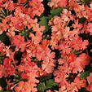 Peachy Keen – large peach tone blossoms from apricot to cream in abundance; 6-12” ht, 18 – 24” spread, trails to 24”

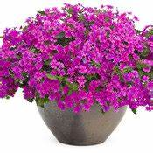 Pink Shades – masses of clusters of large deep rose-pink bloom continuously; ht. 6 – 12”, spread – 18 – 30”, trails to 30”

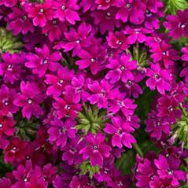 Plum Wine – boasts large clusters of reddish violet flowers; 8-12” ht, trails to 48”

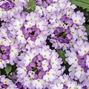 Sparkling Amethyst – bicolored ameythst blue and creamy white flower clusters in profusion; 6 – 12” ht; 18 - 30” spread, trails to 24”

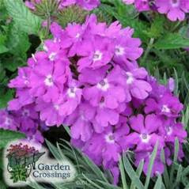 Violet Ice – large clusters of violet blossoms w/ white eyes; 8-12” ht, 24-30” spread, trails to 24”

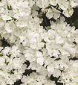 Whiteout – a flurry of pure white flower clusters that form large balls of blooms; 6 – 12” ht, 18 – 30” spread, trails to 24”

AIM/ Feb. 24, 2020

