About us…

Garden Club of Harrington Park - Officers and Committee Chairs

Gerri Gibney President
Ann-Ingrid Millikan Vice-President, Publicity Chair
Irene Jackson Treasurer
Carla Jacobelli Town Beautification Chair
Bev Murray Membership Chair
Dot Durbec Refreshment Chair
Fundraising Hedy Galow
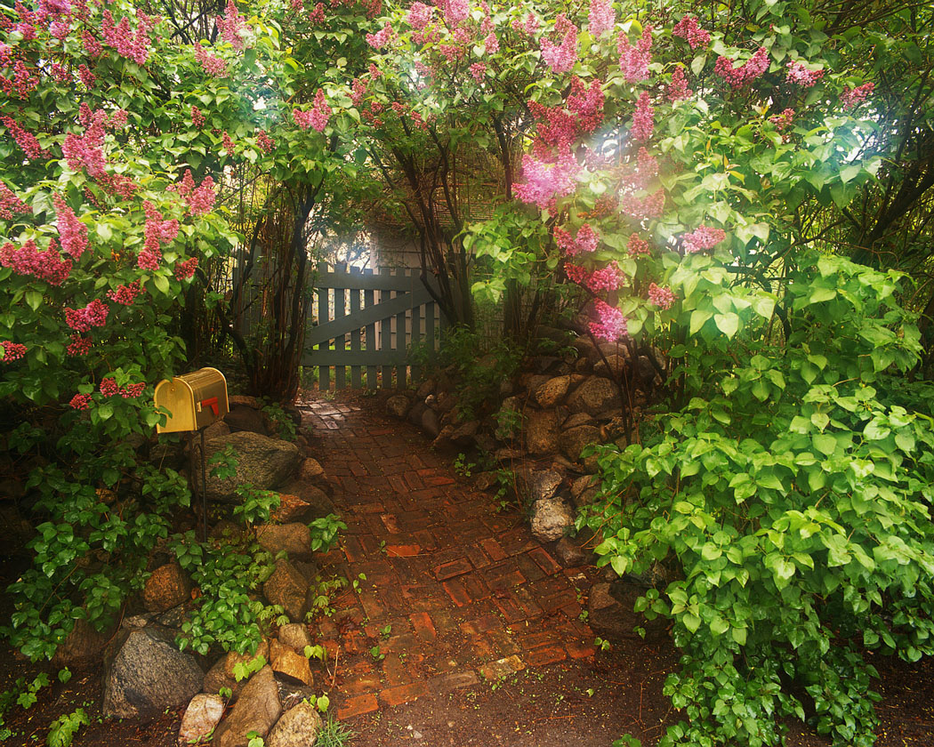
The Garden Club of Harrington Park holds General Meetings the first Thursday of every month (except where otherwise noted) September through June in the Harrington Park Library (second floor). The meetings begin at 7:30 P.M. and include a lecture by a guest speaker on various gardening topics. Each meeting we have a floral contest, whereby members interpret a given theme. We have a Field Trip at the end of our Club year, along with a luncheon. Our meetings are open to everyone who loves a garden and gardening.

Membership is open to anyone with a love of gardening. Whether you are an arm chair gardener or an on your knees dirt gardener – we welcome all. Our dues are $20.00 for an individual and $35.00 for family membership. Our membership is comprised of people, both men and women, who come from many different towns. And, we have all levels of gardening expertise – from the novice to the experienced gardener.

You can enjoy the Garden Club in so many ways; by attending our meetings, and/or volunteering to be a refreshment host, helping with special events, and if you would like, jumping in with both hands for some of our on-going dirt projects, such as the barrel plantings in the downtown area.

These barrels have been purchased and maintained by the Club. Each year we replace the old barrels, if needed, and plant flowers to be enjoyed in the Spring, Summer, and early Fall. Come late Fall we replace the spent flowers with small trees to last the Winter into the early Spring. During the growing season, you might want to join the “Water Wizards.” The Wizards sign-up to water the plant life in the barrels to keep them fresh and beautiful.

The Club’s major fundraiser for the year is a perennial plant sale held in April. At that time, we also take orders for annual plants that are ready for delivery in mid May.

We also plan and plant the entrance to the “Old Burying Grounds” on Tappan Road in Harrington Park.

And, finally, we will be planting a tree at Don Horsey Park in Harrington Park to commemorate our 30th anniversary in 2020.

For further information about the Garden Club, please call Gerri Gibney at 201 768-2615.

