Garden Club of Harrington Park
2022-2023 Meetings and Events

The Garden Club or Harrington Park holds General Meetings the first Thursday of every month (except where otherwise noted) September through June in the Harrington Park Library (second floor). The meetings begin at 7:30 P.M. and include a lecture by a guest speaker on various gardening topics, followed by a Q & A, and refreshments. Each meeting we have a floral contest, whereby members interpret a given theme.

Traditionally, in June we have a field trip and luncheon, and on occasion, we have mini-field trips to a garden, a garden show, or anything garden!

September 8, 2022
Speaker: Tom Bender, Leader of the Bergen-Passaic Chapter of The Native Plant Society of New Jersey
Topic: “Deer Resistant Plants with an Emphasis on Natives”

October 6, 2022
Janet Schulz, Master Gardener
Topic: “Spring Ephemerals & Seed Disbursement”

Nov. 3, 2022
Speaker: Marc Gussen, Director Closter Nature Center
Topic: “Hydroponics – An Alternative to Dirt”

Nov. 5, 2022 – Winterize Barrels

November 20, 2022 – 2:00 P.M. “Thanksgiving Centerpiece Workshop” –Conducted by Gerri Gibney – Fee $22.00 Members, $27.00 Non-Members
Pre-Registration Required – contact themerchantmouse@aol.com or 201 768-2615

December 1, 2022
Speaker: Gerri Gibney
Topic: Hands on Workshop
Tree or Wreath
Make-It and Take-It

December 16, 2022
Garden Club Holiday Get-Together – Pot Luck “Nibbles and Sweets” at Gerri Gibney’s – 7:00 P.M.

January 5, 2023
Chair: Esther Ross
“Members’ Night & Winners & Losers in the Garden” – A Fun Evening of Garden Club Members’ “Power Point Show and Tell” of Their Own Gardens, Gardens Visited, or Anything Garden

February 2, 2023
Speaker: Jeff VanPelt, Retired Horticulture Supervisor of the Somerset County Park Commission
Topic: “Spring/Fall Cleanup & Splitting Perennials”

March 2, 2023
Speaker: Chris Raimondi, Owner, Raimondi Horticultural Group
Topic: “New Trending Seasonal Annuals for 2023”

April 6, 2023
Speaker: David Daehnke, “The Garden Guru”
Topic: “Ornamental Grasses”

April 29, 2022 – Garden Club Plant Sale (Many Homegrown Plants) – Annual Fundraiser held at the Library Parking Lot – 9:00 A.M. – Noon

May 4, 2023 – Garden Club Plant Swap
Speaker: Marc Zukovich, Owner Sterling Horticultural Services
Topic: “Ferns & Other Shady Perennials”

May 13, 2023 – Barrel Planting -
10:00 A.M.
Chair: Carla Jacobelli
Beautification of Downtown H.P.

June 3, 2023 – 10:00 A.M.
Tour of Members’ Gardens and Pot Luck Barbecue

June 17, 2023 – Annual Field Trip & Luncheon
Depart Library Parking Lot at 9:00 A.M. – Car Pool to Willowwood Arboretum, Far Hills, N.J. – Docent Tour, Luncheon to Follow

We Celebrated Our 30th Anniversary in May 2020

Garden Club of Harrington Park
Membership

Membership is open to anyone with a love of gardening. Whether you are an arm chair gardener or an on your knees dirt gardener – we welcome all. Incidentally, we have both men and women members in our Club – we were one of the first garden clubs in New Jersey to have both, because, since our inception we have met in the evening! You do not have to be a resident of Harrington Park, many of our members are from surrounding towns.

Our dues are:
Individual - $20.00
Family - $35.00

If you are interested in becoming a member of the Garden Club, please send your check, made payable to the Garden Club of Harrington Park, to Beverly Murray, 363 High St., Closter NJ 07624-2004. Please include your address, phone number, and e-mail.

Opportunities for Fun

You can enjoy the Garden Club in so many ways; by attending our meetings, and/or volunteering to be a refreshment host, helping with special events, and, if you would like, jumping in with both hands for some of our on-going dirt projects, such as the barrel plantings in the downtown area.

These barrels have been purchased and maintained by the Club. Each year we replace the old barrels, if needed, and plant flowers to be enjoyed in the spring, summer, and early fall. Come late fall we replace the spent flowers with evergreens to last the winter into the early spring. During the growing season, you might want to join the “Water Wizards.” The Wizards sign-up to water the plant life in the barrels to keep them fresh and beautiful.

This Club year we plan to have a Spring Plant Sale for our fundraiser. This will need helping hands too.

Affiliations

We are members of the Garden Club of New Jersey and the Garden Club of America.

Information about the Garden Club, please call Gerri Gibney at 201 768-2615 or 201 913-8459, themerchantmouse@aol.com – We’re on Facebook – friend us!
www.gardenclubofharringtonpark.com

NOTES

Garden Club
of
Harrington Park
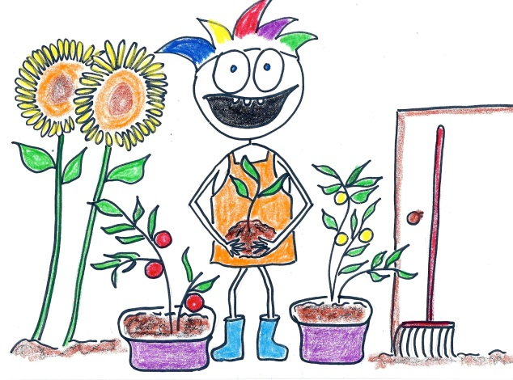
Meetings
and
Events

2022 - 2023

