Garden Club of Harrington Park
154 LaRoche Avenue
Harrington Park, New Jersey 07640
www.gardenclubofharringtonpark.com

February 27, 2011

TO: Members & Friends – Garden Club of Harrington Park

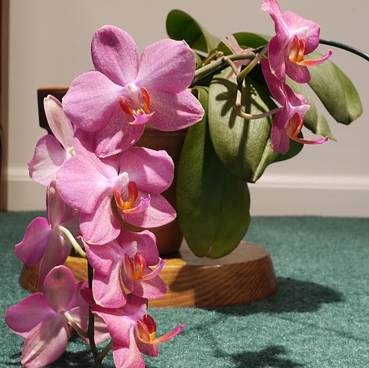
Chris Rubino from Monrovia Nurseries was fabulous! If you missed Chris, shame on you! His lecture on the new introductions from Monrovia was great! We will have Chris back next year in February. He really knows his stuff, and what a great personality! I think it safe to say we were all charmed. Esther Ross won the floral contest, “Chasing the Winter Blahs” with her entry of a glorious orchid. I don’t know how she does it, but it has bloomed for her for quite a few years. Here’s a picture of it – lovely!

You can enter the next contest, “Wearing of the Green” at our March 3rd meeting.

The Executive Committee has been busy putting together our list of annuals we will be selling as part of our major fundraiser for the year. The list will be competed very soon, and we’ll get it out to you ASAP. This year we are using the same supplier for the annuals as we have been using for the perennials. It’s a long trip to pick up the plants, Cicconi Farms is near Belmar, New Jersey, but the plants are top notch so it’s worth it. We will be using a truck on loan from David Miller, a realtor, who loans it out to organizations such as ours.

The perennial plant sale is Saturday, April 30th, from 9:00 A.M. until Noon in the library parking lot. We are asking for your help by bringing as many of your own “extra” perennials as possible. The reason is twofold; home grown plants are the best, and they represent pure profit for the club. We would really like to advertise that we are heavy on the home growns, so please, please start thinking of the plants you might be able to dig up and split to bring to the sale. If you know you have some you will be bringing, please e-mail me. This way we can advertise that we will have a particular plant. We will, of course, have the perennials we purchase from Cicconi Farms, but your plants will bring other gardeners from far and wide, and will make the sale really special!

At our March meeting I will have a sign-up sheet to work the sale. You don’t need to stay for the entire time, it’s up to you. We’ll split up the schedule in hour shifts, but if past history is any indicator, many of you come and work the entire time because it is so much fun! You get to see many old friends and acquaintances and you make new ones! One thing I ask, pray for good weather, or, at the very least, no rain. For your information, the town will be selling the compost that day too.

Here’s an unabashed plug from the Harrington Park Historical Society for its annual History Day, which as it turns out is the same day as our plant sale. The Historical Society has incorporated History Day into “Heritage Weekend.” The schedule for this weekend is; Saturday in Boro Hall will be exhibits of history with a special section in commemoration of the 100th anniversary of the H.P. Fire Department this year. The exhibit will be on display from 10:00 A.M. until Noon. At 1:30 P.M. we welcome President Abraham Lincoln. President Lincoln’s appearance is especially pertinent since it is the 150th anniversary of the Civil War, and he will be talking about the war years. After his address, the Society will be serving tea along with tales (Tea and Tales) from long time residents of Harrington Park. On Sunday, at 1:00 P.M. a tour of the Old Burying Ground on Tappan Road will be given by John Mager and Dave Ross, and at 3:00 P.M. a walking tour of early homes will commence. You’re invited to attend all of these events as part of “Heritage Weekend!”

We published this before, but it’s worth repeating; the following is a list of a few of the upcoming flower shows:

Philadelphia Flower Show – “Springtime in Paris”

March 6-13 – Philadelphia Convention Center
www.theflowershow.com

Springfest Flower & Garden Show
March 17-20 – Sussex County Fairgrounds, Frankford, New Jersey
www.springfestgardenshow.org

The last few years, we’ve made a mini field trip to the Springfest Show. We’ll do it again on Saturday, March 19th, leaving Harrington Park at 9:00 A.M. After we tour the show we’ll go to lunch. This is a great little show, and for me it is the entry into spring! Hope you can come along – it’s a lot of fun. We’ll have a sign-up sheet at the March meeting.

We received the following e-mail from the Ramsey Garden Club about their trip to the Philadelphia Show:

The Ramsey Area Garden Club is again sponsoring a trip to the Philadelphia Flower Show (and the way this winter is evolving, we will need it!) We have the date: Monday, March 7, 2010 (Note: Snow date will be Wednesday, March 8, 2010). We have the tickets. We have the bus. We have the snacks. WE NEED YOU!!!!!! The tickets are $55.00 per person. We will be leaving from the Finch Park (Island Road) parking lot in Ramsey at 9am (sharp) and returning from Philadelphia at 6pm.

PLEASE E:MAIL OR CALL (201-327-1668) ME TO RESERVE YOUR PLACE(S).

KAREN KAMINSKI
34 SPRUCE RUN
RAMSEY, NEW JERSEY 07446.

This e-mail says it all! I know some of you have gone down to the Philadelphia Show with the Ramsey Club, so I thought I’d pass this along (again).

Did you notice that there has been something added to the masthead of the newsletter? Well, if you didn’t, I’m going to tell you. We have a website! It’s www.gardenclubofharringtonpark.com. Check it out and let me know what you think! It’s a work in progress, but we’re out there. If you have suggestions, please let me know. On the website we’ve included links to our newsletter, a tips page on what to do in the garden monthly, and photographs of the barrels we plant in the downtown area. One of the things we might do is have a “Members’ Page.” We can do lots of things, but for the time being, it’s a start!

Here’s the press release submitted by Ann-Ingrid Millikan for our next Club meeting:

Come visit New Jersey's beautiful, diverse gardens and discover more about your favorites and those you have yet to visit at The Garden Club of Harrington Park's meeting, March 3rd, at 7:30 P.M., in the Harrington Park Library, 10 Herring Street. Guest speakers Bonnie Joachim and Dawn Healey, members of The Garden State Gardens, a consortium of New Jersey Public Gardens, will present "Exploring New Jersey Gardens", a power point program examining many of the premier and "secret" public gardens in our Garden State.

The consortium is a non-profit organization dedicated to increasing the public's awareness of and appreciation for the beauty and horticultural, educational, artistic and historic value of New Jersey's public gardens. More than 18 gardens are included in the consortium, many of them familiar, some not so, including: the Bamboo Brook Outdoor Education Center, Chester Township; Colonial Park Gardens, East Millstone; Morven Museum and Garden, Princeton; The Frelinghuysen Arboretum, Morris County; Presby Iris Gardens, Upper Mountclair.

Bonnie is the past president and a current board member of the Friends of Laurelwood Arboretum in Wayne, New Jersey, and has served as an officer on the boards of the Passaic County Master Gardener Assoc. and the New Jersey Master Gardener Assoc. Dawn is a board member of the Friends of Laurelwood Arboretum, a Passaic County Master Gardener and is current vice-president of the Caldwell Photo Club.
As always, conversation, yummy desserts and coffee will follow the meeting. After reading this, I think I’ll go!

You know the seasons are changing when Charlie (across from the Oradell train station) sets up his risers in preparation for the pansy invasion. For those who don’t know what I am talking about, and asking “who is Charlie?” He runs a small plant stand, a block off of Kinderkamack Road directly across from the RR station. He typically sells pansies at the beginning of the season, moves into perennials, vegetables, and flats of the common annuals. The risers, for me, are a sure sign that spring is here! And, on a personal note; another sign for me is my 91 year old dad planting tomato, beans, other various vegetables, and flower seeds! Many of them have already germinated, so I know I’ll have some great tomato plants this year.

See you Thursday night – bring a friend, or two…

Until we meet again, keep your feet dry and your hands dirty…

Gerri Gibney

