FROM THE KITCHEN OF DOT DURBEC

SERVED AT THE GARDEN CLUB OF HARRINGTON PARK MEETING
JANUARY 8, 2015
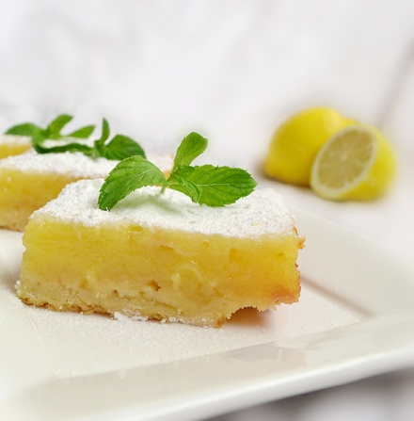
Lemon Curd Bars:

l C unsalted butter, softened
l C sugar
2 C flour
l/2 teas. baking powder
l l0-l2 ounce jar lemon curd
2/3 C flaked coconut
l/2 C slivered almonds or coarsely chopped pecans, toasted

In a large bowl, beat butter, add sugar, beat together, add flour & baking powder,beat just until mixture resembles coarse crumbs. Reserve 2/3 cup of the crumb mixture, set aside. Press the remaining crumb mixture into bottom of a greased l3 x 9 x 2 inch baking pan. Bake for 5 to 8 min. until top is golden. Remove from oven. Spread lemon curd over hot crust to within 1/2 inch of edge of pan. In a medium bowl, combine the reserved crumb mixture, coconut, and almonds. Sprinkle crumb mixture over lemon curd. Bake for l8 to 20 min. ,until edges are golden. Cool in pan.

375 degree oven.

